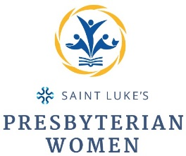
2021-2022 Coordinating Team

Title/Project | Name
Moderator | Nan Keel
Vice Moderator | Janis Kilgore
Secretary | Donna Crutchfield
Treasurer | Becky Loftis
Church Women United | Pat Troxel
Thornwell | Christy Keohane
Fundraising | Kimey Reed, Diane Lemaster
Membership | Stephanie McGoldrick
Former Moderator, Search | Jenny Troha
Spiritual Growth | Nancy Moore, Sandra DuBois
Chrismons | Lucy Painter
Santa Claus Express | Ellen Womack
Christmas Dinner | Terri Potter, Mary Martin
Sandwich Project | Amanda Lower, Martha Tate
Valentine Boxes | Sylvia Jackson, Joy Babcock
Women’s Retreat | Faye Cashwell, Sally Joyce,  Debbie Parks, Martha Tate
Easter Baskets | Kay Moe, Jenny Troha
Circle 1 - Leader | Ellen Womack
Circle 1 Bible Moderator | Ann Richardson
Circle 2 - Leader | Sally Larson, Faye Cashwell
Circle 2 Bible Moderator | Faye Cashwell
Night Circle - Leader | Jean Cronan
Night Circle Bible Moderator(s) | Marylyn Brown, Sally Harvey

